
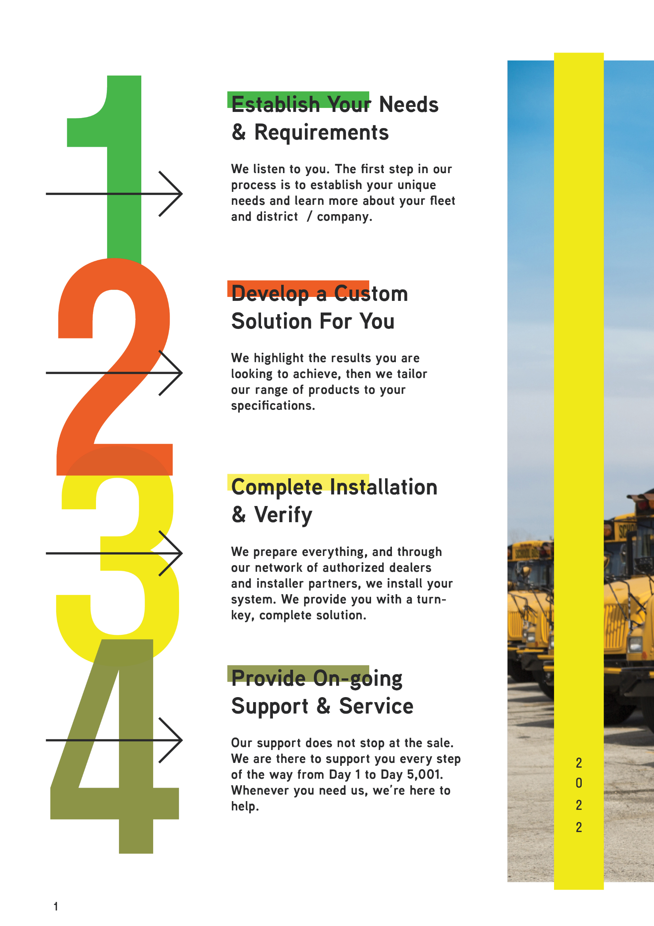
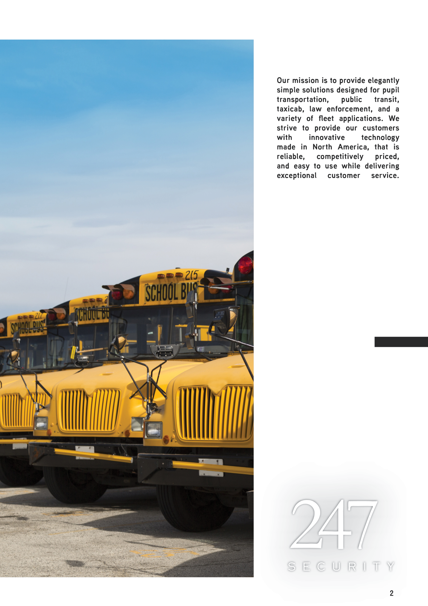
The Solution For Jade County, Texas

All Systems Include:  - Zeus TITAN  - Infinity Drive (120GB SSD, 2TB HDD) – lifetime warranty  - E-Guard Power Loss Recording Protection  o Continues to record after complete power loss. With other systems youlose minutes BEFORE the power loss  - OmniView 360° Cameras  - 1080p Full HD Resolution  - Audio on every camera  - IR day/night cameras  - Low Profile  - Detailed coverage into high-back seats  - ShieldCam TM per Bus  - Mounts on Windshield for less vibration  - Minimal Visual Obstruction  - Designed for Maximum Safety  - All cabling included  - Wireless Access Point for Zeus -PT Series  o WIFI-5G-ap2  53 – Large Passenger Buses 5 Camera Set-up  - 4 - OmniView 360° Cameras – per bus system  - 1 - ShieldCam TM per Bus  6 – Small Passenger Buses 4 Camera Set-up  - 3 - OmniView 360° Cameras – per bus system  - 1 - ShieldCam TM per Bus  4 – Small Passenger Van 2 Camera Set-up  - 1 - OmniView 360° Cameras – per bus system  - 1 - ShieldCam TM per Bus  2 – Touchdown Building Access Point Upgrade  o Upgrades access points to 5GHz for faster download speeds | $143,171.00
Subtotal: | $143,171.00
Discount: | $10,0000
Sales Tax: | $6,985.47
Shipping: | $945.00
Installation: | $21,861.00
Total Solution: | $119,926.47



